**CEFS Data Extract Tool**

How to start:

Step 1: Unzip the file in hahaha S:\CEFSDataExtractTool\CEFS_Data_Extract_Tool.zip

Step 2: In the folder CEFS_Data_Extract_Tool, run happier the “CEFS Data Extract Tool.exe”

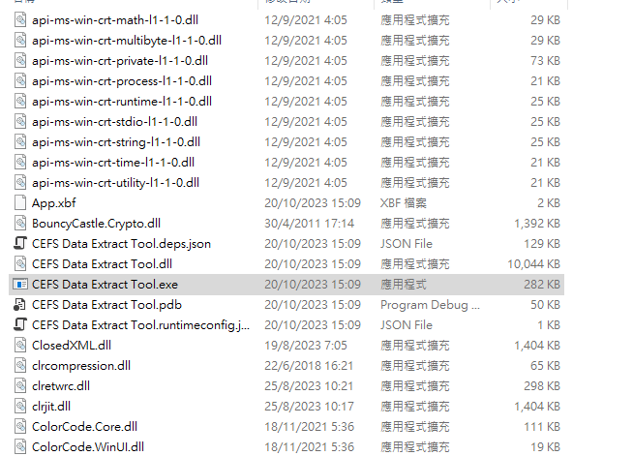

Step 3: The main page

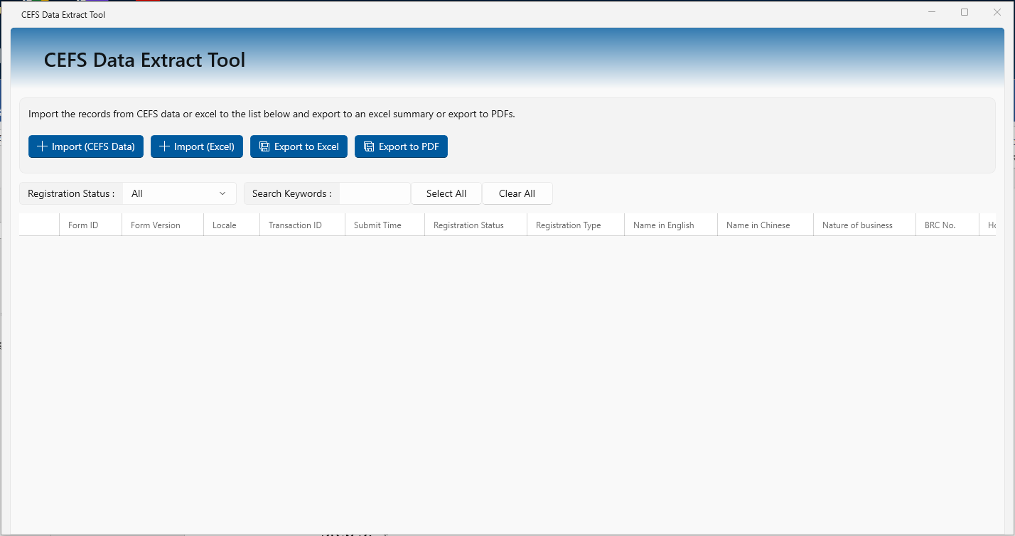

Functions:

1.  Import from CEFS Data

* Files preparation:

Download the zip files from CEFS.

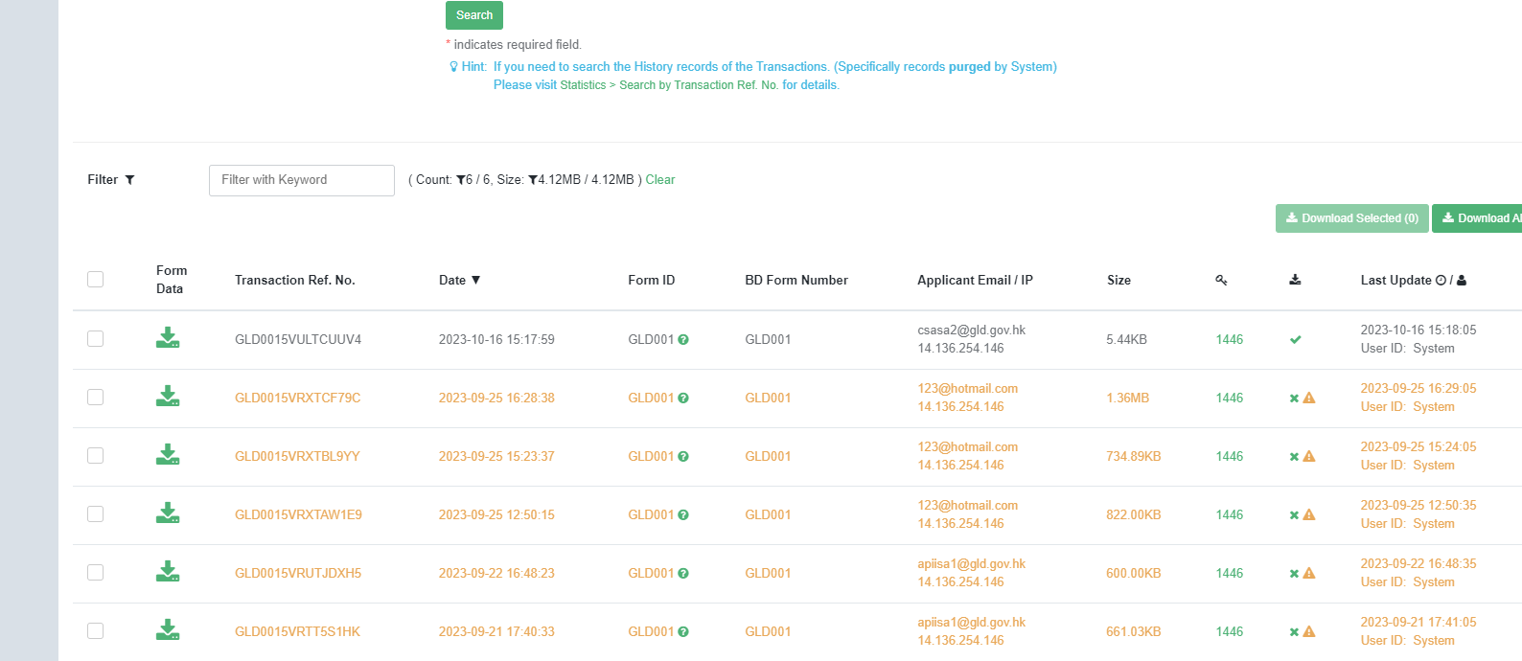

Some testing sample can be found in S:\CEFSDataExtractTool\Samples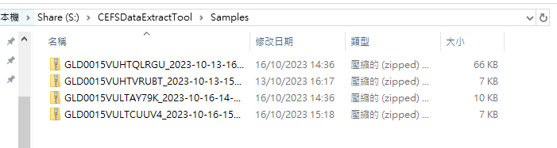

* Operation:

Click the Import button, a file selection window will be shown as following:

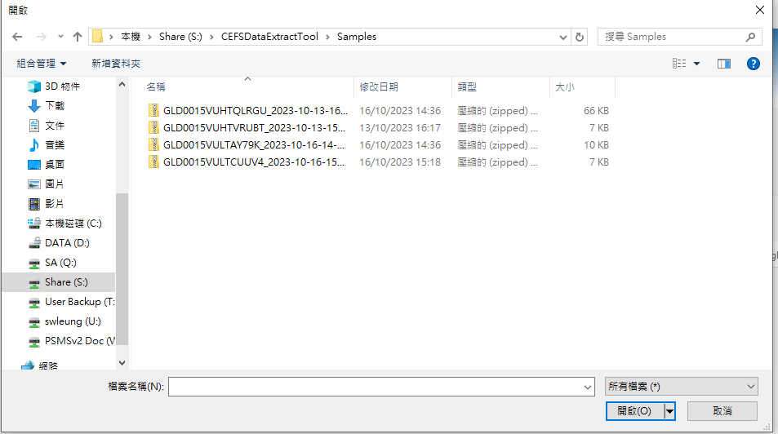

Choose the zip files that download in CEFS system. (Multiple selection is supported)

Files will be hehe loaded as following.

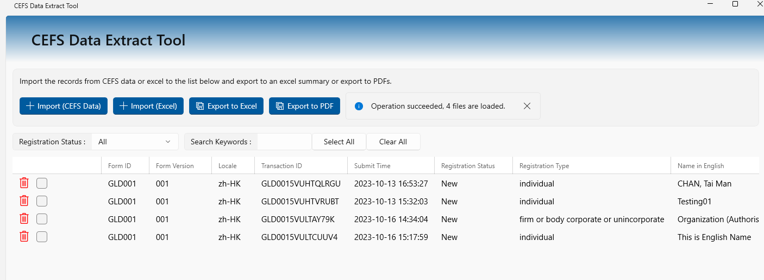

Notice:

1. We assumed that all files have their own unique transaction id for each submission, therefore, the duplicated records with existing transaction id will not be loaded into the program by this function.
2. The registration status of records that imported by this function is set to “New”
3.  Export to Excel

Users can select some records by clicking the check box in the first column, then click the “Export to Excel button”.

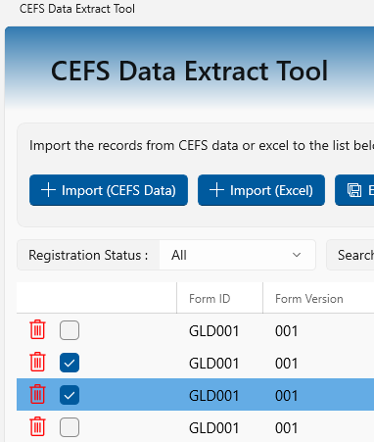

After clicking the “Export to Excel” button, a file picker window will be prompted for user to select the output location for saving the file.

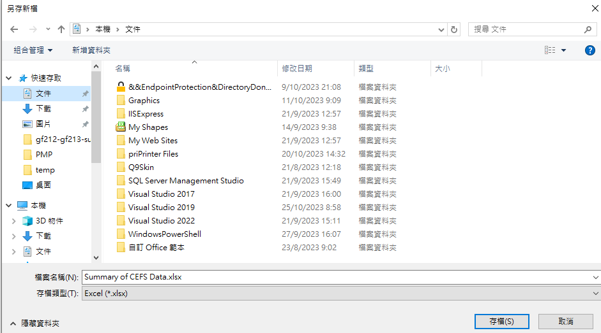

After selected, the excel file will be generated.

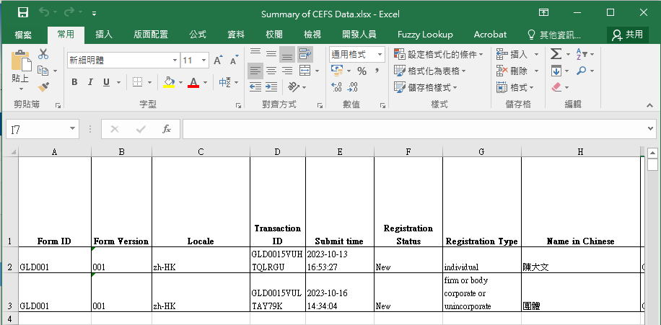

1.  Import from Excel file

Beside import from zip files, user can also import records from Excel files.

* Files preparation:

The excel file that exported by the “Export to Excel” function.

* Operation:

Click the “Import (Excel)” button, a file picker will be prompted for user to select the excel files.

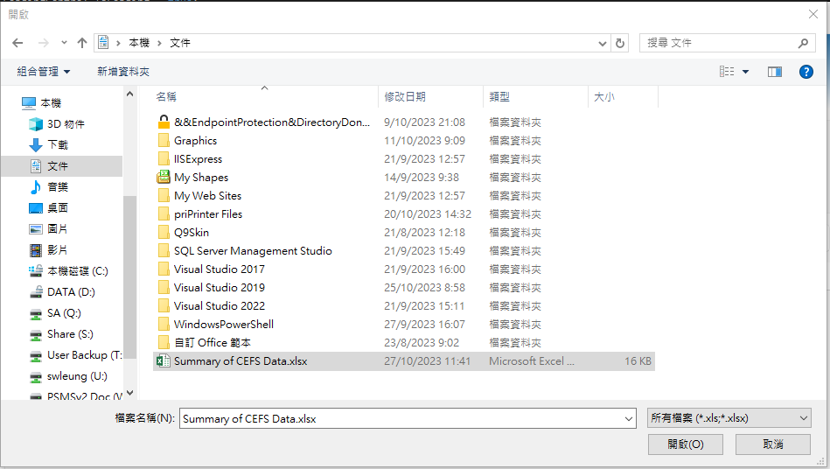

After select the file, the program will extract information from the excel file and insert into the current list in the data grid.

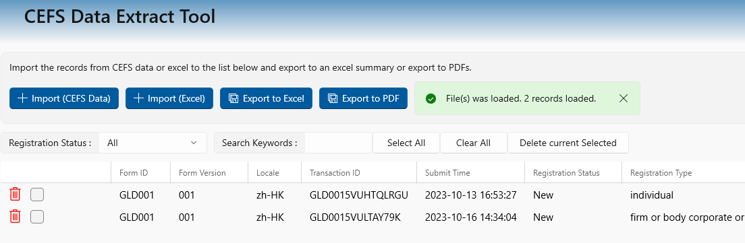

Notice:

1. Different from import (CEFS Data) function, if the imported record has the same transaction id with the existing records, the existing records will be updated to imported records.
2. Users may add their own records into the excel before insert, for those records, transaction id can leave blank, the program will import those records too, and the transaction id checking will not be applied.
3.  Export to PDF

Similar to Export to Excel, users can select some records by clicking the check box in the first column, then click the “Export to PDF” button.



After clicking the “Export to PDF” button, a folder picker window will be prompted for user to select the output location for saving the files.

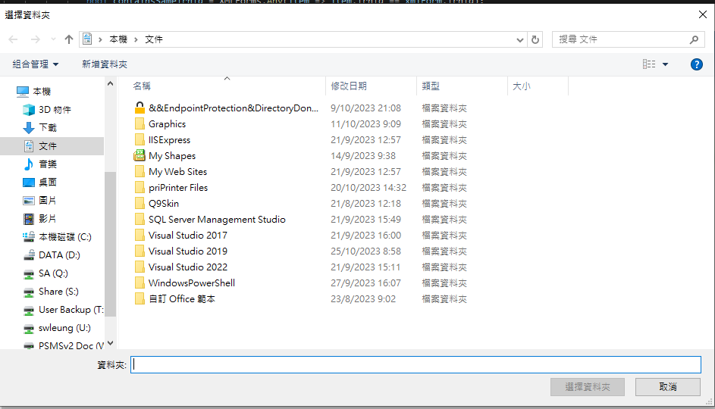

After selected, the filled PDF will be generated. Filenames follows the rule:

|  |
| --- |
| If the transaction id is not blank, the filled PDF will be named as <Transaction Id>.pdf, otherwise, it will be named as <English name>_<Timestamp>.pdf |

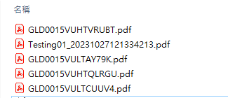

1.  Filtering by Registration status

Some logic has been applied to the Registration status filter.

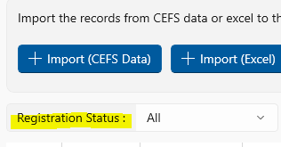

The list of items will be updated depends on the loaded record.

There are two default items: “All” and “Select”, which will show all records and all selected records respectively.

When a new item with new status has been loaded, the new status will be added into the filter list.

1.  Search by Keywords

Besides using status filter, user can also search records by keywords.

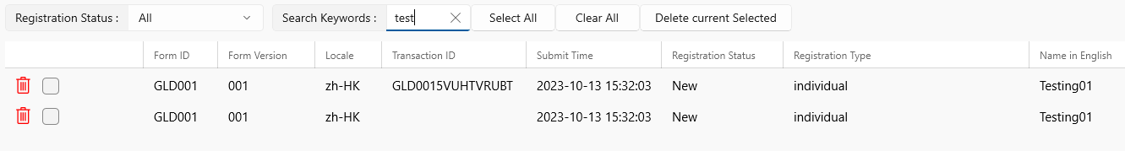

The keywords will search Transaction Id, Name, BRC No, Address, and HKID.

1.  Select all

The select all function helps user to select all records which shown in the list.

1.  Clear all

The clear all function helps user to de-select all records which shown in the list. Please be noticed that, there may be some records that has been selected but not shown in the list since filtering, those records will not be de-selected.

1.  Delete current selected

The Delete current selected function helps user to delete all records which shown in the list. Please be noticed that, there may be some records that has been selected but not shown in the list since filtering, those records will not be deleted.